The National University of Lesotho
Department of Mathematics and Computer Science
Faculty of Science and technology

CS4433: Software Engineering
Task: Phase 1: Project Planning and Management
Due: 02/10/2026
Participants:
 | Student Number | Surname, initials | Major
 | 202322467 | Lephoto L. | B. Sc. Information Systems

Contents
1. Introduction 3
2.Feasibility Study 3
2.1 Technical Feasibility 3
2.2 Operational Feasibility 3
2.3 Economic Feasibility 4
2.4 Legal Feasibility 4
2.5 Schedule Feasibility 4
2.6 Overall Recommendation 5
3. Work breakdown Structure 5
4. Schedule 6
5. Risk Register 6

1. Introduction
This document constitutes the Project Management Plan for the development of a Moderated Learning Management System (LMS) for a secondary school. The system will be developed as an individual project over seven weeks, following the Waterfall development model with V-Model verification and validation. The plan covers the feasibility study, work breakdown structure, schedule, risk management, and initial stakeholder analysis, forming the basis for all subsequent project phases.

The system will be implemented in C++17, using SQLite for persistent storage, CMake for build management, Git for version control, GoogleTest or Catch2 for unit testing, and a static analyser for quality assurance. The system will operate offline on a single school computer or local network and must support four user roles: Student, Lecturer, Head of Department (HoD), and Administrator.

2.Feasibility Study

2.1 Technical Feasibility
The language is widely supported, and compilers not hard to source and find. SQLite is a single-file, serverless, zero-configuration database and it is local which eliminates network dependency. It is perfect for a single school computer or small network, meaning that it can handle the 800 users well enough. With indexed lookups, SQLite also handles this in milliseconds. CMake is a cross-platform tool and well documeneted. The user interface requires no complicated GUI framework, that makes a simple role-based menu achievable. Argon2id or bcrypt provides password hashing which makes security feasible. GoogleTest/Catch2 integrate cleanly with CMake and CI.
The system can therefore be considered feasible, with the main technical risk being integration complexity (SQLite + password hashing + testing framework + CI), not the technology itself.

2.2 Operational Feasibility
The system ha four roles: Student, Lecturer, HoD, Administrator. All are non-IT experts, this means that console menus must be self-explanatory and each role sees only its permitted actions. There is minima ltraining required and user manuals shall be provided per role and if need be, a short induction. Deployment will be to a single school computer or a local network, and the IT officer requires the system to operate offline. Some users may resist a new system, but this will be mitigated by simplicity and training. The HOD must approve the marks before release, this adds another step but is non-negotiable.
The system is therefore operationally feasible provided the console UI is kept simple and the moderation workflow is clearly explained to staff. The biggest operational risk is user adoption, not technology.

2.3 Economic Feasibility
The project is economically feasible within the assumptions provided by the case study. The system is intended to run on existing school computers or a local network rather than requiring an online infrastructure. The use of C++, SQLite, Git and other specified development tools also avoids the need to introduce a large commercial software infrastructure.
Potential costs include development time, installation, training, maintenance and possible hardware upgrades if existing computers cannot meet the system requirements. Expected benefits include reduced manual administration, centralised assessment records, easier monitoring of submissions, controlled release of marks, better tracking of mark changes and reduced risk of lost or inconsistent assessment records.

2.4 Legal Feasibility
The system will process learners' personal and academic information, including user credentials, submissions, marks and feedback. Consequently, legal requirements concerning personal information, confidentiality and security must be considered.
The system must implement appropriate access controls, password protection, secure handling of assessment records and controlled access to marks. A specific legal compliance assessment will need to identify the applicable legislation during the professional, legal and ethical stage. The assignment does not specify a particular statute, so one should not be invented at this stage.

2.5 Schedule Feasibility
The project has a fixed duration of seven weeks. Planning and requirements begin in Week 1, requirements continue through Week 2, design takes place in Weeks 2–3, implementation in Weeks 4–5, verification and validation in Weeks 5–6, deployment in Week 6, and maintenance and completion in Week 7.
The schedule is demanding because the project requires not only implementation but also UML, database design, automated testing, CI, static analysis, deployment documentation and a maintenance release. However, the scope is clearly defined and the system is deliberately limited to a local C++ application. Therefore, the schedule is achievable with effective planning and strict scope control.

2.6 Overall Recommendation
All required technologies are free, mature, and offline-capable. The only significant risks are (a) design rework after Gate 2 and (b) user adoption. Both are manageable through disciplined change control and simple UI design. No alternative (e.g., web-based, cloud-hosted) is justified given the offline constraint and single-computer deployment.
The project is feasible for development. The technology, operating environment and scope are manageable, while the proposed system provides identifiable operational benefits. However, successful completion depends on controlling scope, completing requirements and design before implementation, addressing security and legal requirements, and closely monitoring the seven-week schedule.

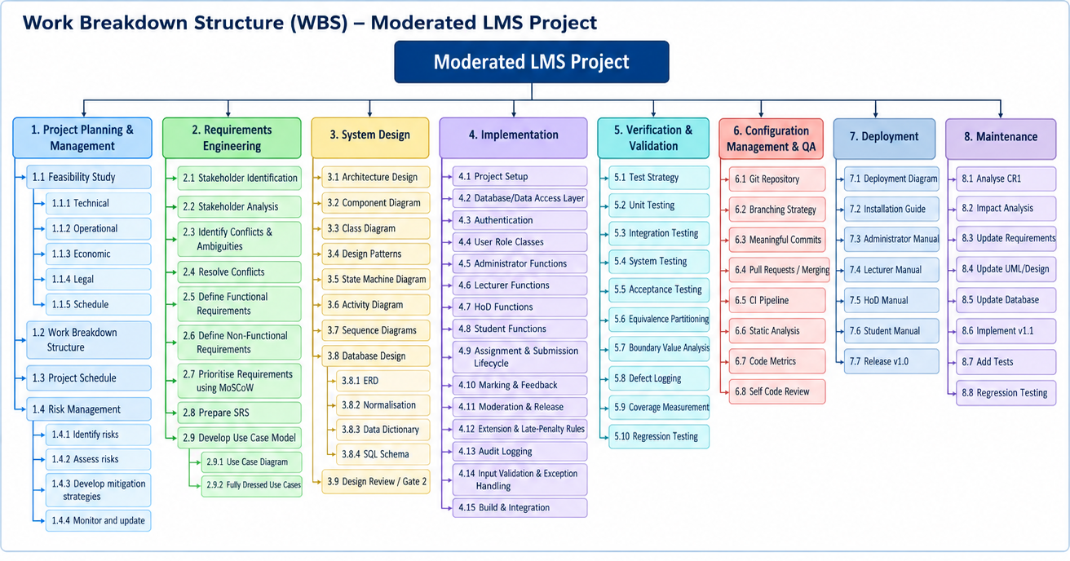
3. Work breakdown Structure

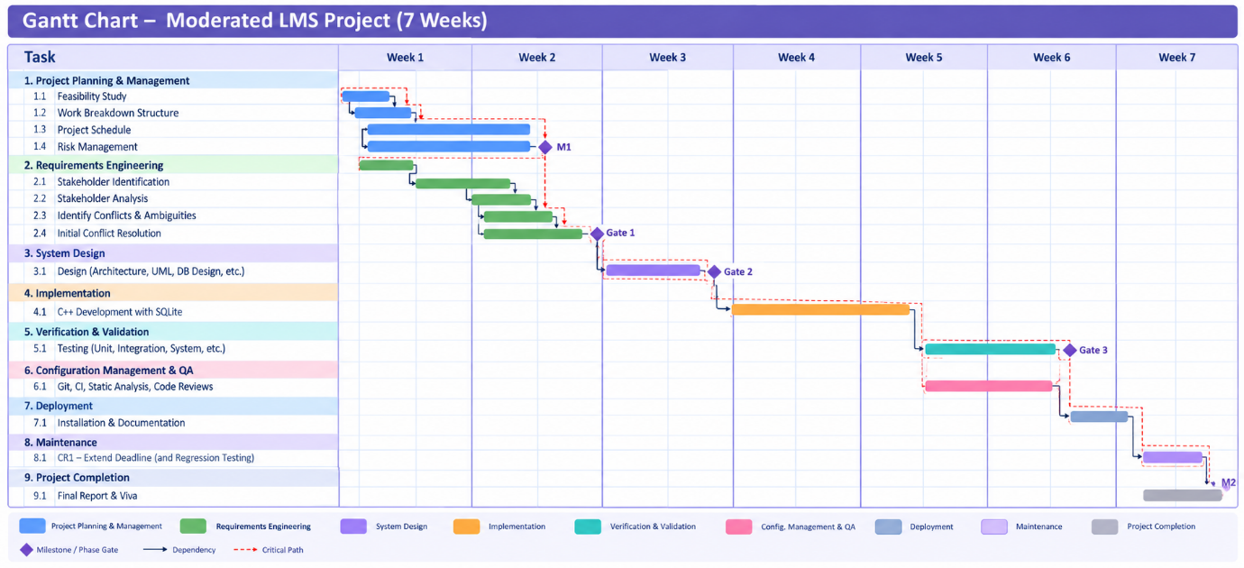
4. Schedule

5. Risk Register
ID | Risk | Type | Likelihood | Impact | Exposure | Mitigation | Owner
R1 | Requirements are misunderstood or remain ambiguous | Project | 3 | 5 | 15 | Stakeholder analysis, conflict resolution and requirements review before Gate 1 | Project Manager
R2 | Seven-week schedule is insufficient | Project | 4 | 5 | 20 | Detailed schedule, milestone monitoring and scope control | Project Manager
R3 | C++/SQLite implementation difficulties delay development | Technical | 3 | 4 | 12 | Prototype database access early and follow approved architecture | Developer
R4 | Security vulnerabilities in authentication or database access | Technical | 3 | 5 | 15 | Salted password hashes, parameterised queries and security testing | Developer
R5 | Design and implementation become inconsistent | Technical | 3 | 4 | 12 | Traceability between requirements, UML, database, code and tests | Project Manager / Developer
R6 | Insufficient testing results in undetected defects | Technical | 3 | 5 | 15 | Automated unit/integration tests plus system and acceptance testing | Tester
R7 | Users find the system difficult to use | People | 3 | 4 | 12 | Simple workflows and user manuals/training | UX/Project Team
R8 | Loss or corruption of project/source-code files | Technical | 2 | 5 | 10 | Hosted Git repository, regular commits and tagged releases | Developer
R9 | Late requirement changes cause rework | Project | 3 | 4 | 12 | Change control and impact analysis | Project Manager
R10 | Stakeholders disagree about mark-release or late-penalty rules | People | 3 | 4 | 12 | Resolve conflicts during requirements engineering and document agreed rules | Project Manager / HoD

